Year 10
Pathway 2

Test 2

2018


Name: ______________________ Class: ______ Time: 35 minutes Total Mark:____/35

Show working and answers on this sheet. Show working in sufficient detail to support your answers. Incorrect answers without supporting reasoning will be allocated zero marks.

Resources: 1 A4 page of notes (1 side), Calculator allowed.

Question 1 10 marks

Solve each of the following equations (that is, find the value for the pronumeral that makes each statement true).
a) | $$x+2=8$$ | b) | $$6k=36$$
c) | $$\frac{w}{5}=-9$$ | d) | $$5a+6=26$$
e) | $$\frac{f}{4}+6=16$$ | f) | $$\frac{x}{2}- \frac{3x}{5}=\frac{1}{4}$$

Question 2 2 marks

Use the graphs below of the given simultaneous equations to write the point of intersection and, hence, the solution of the simultaneous equation.
Equation 1: $x-y=1$
Equation 2: $x+y=3$
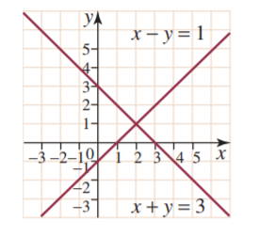

Question 3 5 marks

Plot the following linear graphs for the given range of $x$ – values on the same Cartesian plane:
a) | $$y=x+2$$ | b) | $$y=2x$$
 | $$x$$ 0 1 2 3  $$y$$ |  | $$x$$ 0 1 2 3  $$y$$

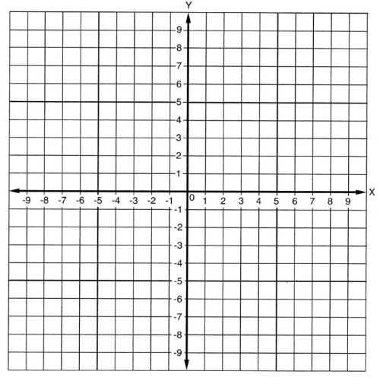
c) Use these graphs to determine the point of intersection and, hence, the solution of the simultaneous equations.

Question 4 5 marks

Solve the following pair of simulations equations using a graphical method
  - $y=2x+3$
  - $y=\frac{1}{2}x+1$



  - Use these graphs to determine the point of intersection and, hence, the solution of the simultaneous equations.

Question 5 6 marks

Solve the following pair of simultaneous equations:
$$y=5x-8$$
$$y=-3x+16$$

Question 6 3 marks

Decide if the graph of each pair of rules will be parallel, perpendicular or neither
  - $y=-3x-8$ and $y= \frac{1}{3}x+1$

  - $y=\frac{1}{2}x+2$ and $y=\frac{1}{2}x-4$

Question 7 4 marks

Find the equation of the straight line that passes through the point (4, -1) and is parallel to the straight line with equation $y=2x-5$

END OF TEST

